Just like TMS you would be able to add as many search by options as needed
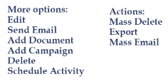

The Add Client, Import Clients and More menu would all be permission based

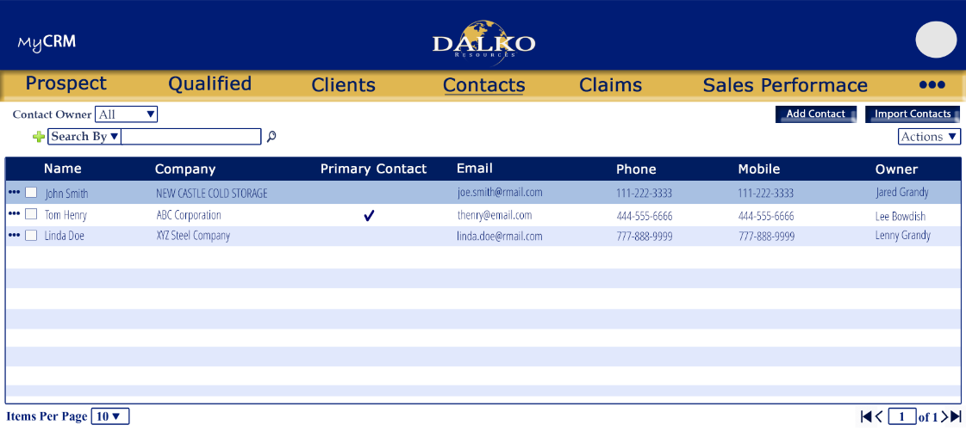

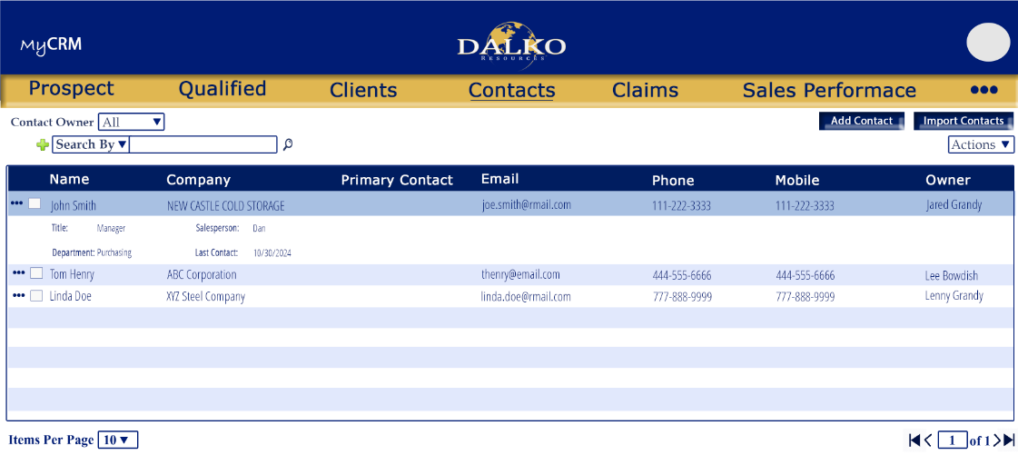

New/Edit
Unlike the current CRM you would not have to click to edit each field. Instead all fields would be open to edit, we would add a Save button and the button would be permission based. That would allow certain users to view details but not save the changes.

If a contact is added in this screen is will also be added to the Company screen and vice versa
If an Activity is added in this screen is will also be added to the Activities and the associated Company screen and vice versa (if we have one)
If a campaign is added in this screen is will also be added to the Campaigns screen as well as the associated Company and vice versa
If a contact log is added under the Contact it will also be added under Contact log under the associated Company and vice versa

Activities More menu Options:


